**Coping Mechanisms**

Young people need to develop personal coping mechanisms and alter their perspective of the stressors that affect them. AIHW reportindicated that **one in five male and one in 10 females aged 18 to 24 years were found to have a substance (alcohol/drug) use disorder**. Combined with the high frequency of mental illness and youth suicide, this indicates that **not** all young people are coping with life.

Key Facts

* In 2007, 25% of young people had a mental disorder (ABS)
* Young women were more likely than young men to have a mental disorder
* Young people with a mental disorder were 5 times more likely to misuse drugs compared to those without a disorder

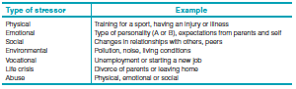

**Types of common stressors**

**Stress**: is a physiological or psychological influence that produces a state of tension in a person.

## Today, young people appear to be experiencing increasing levels of **stress** due to factors beyond their control

# General nature

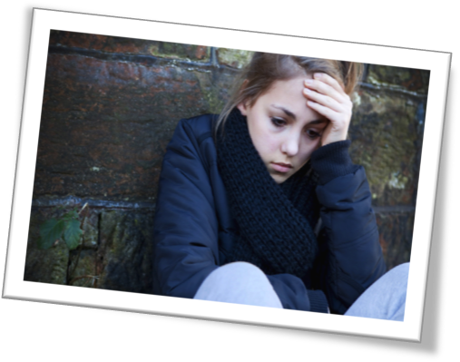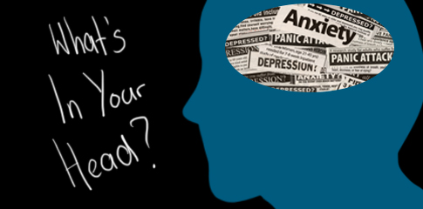

[Date]

Mental health problems and diseases

The Health of Young People

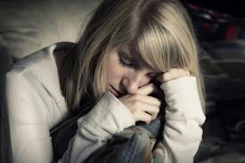

Nunc cursus magna quis

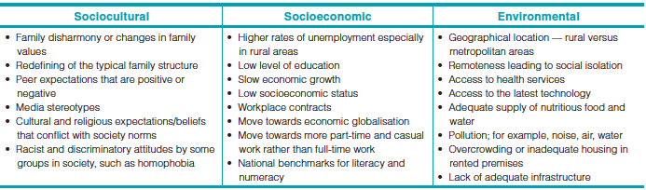

**Vestibulum vehicula purus sed urna.**

Determinants 

**Risk Factors**

***Modifiable***

• Unemployment

• Low level of education

• Geographic location — rural/metro

• Difficulty with issues of sexuality

• Low self-esteem

• Social alienation

• Access to firearms — rural males

• Incarceration

• Family breakdown

• Substance abuse

• Sexually abused as a child

• Low socioeconomic status

***Non-modifiable***

• Migrant background

• Aboriginal and Torres Strait Islander (ABTSI)

background

• Gender

• Family history of mental illness

**Protective factors**

• Strong personal support networks that function in good times and bad

• Personal skills based around assertiveness, resilience, coping, decision making,

problem solving and conflict resolution

• Laws regarding age limits; for example, work, minimum years of schooling, marriage, sexual consent, driving, alcohol consumption and anti-discrimination laws

• Access to health services and the development of health literacy skills by schools, such as Kids Help Line, school counsellors, health pamphlets and government health internet sites

• Education of the community and professionals who deal with young people

• Societal and cultural norms that aim to protect young people from self-harm; for example, censorship and classification restrictions

• Participation of young people in community decision making to enhance feelings of connectedness; for example, student representative council

•

**Young people most at risk of mental health problems and illnesses are:**

• the unemployed or economically disadvantaged

• students who leave school prematurely

• individuals with Aboriginal or Torres Strait Islander backgrounds

• rural males

• females

• gay youth

• individuals who experience incarceration or the juvenile justice system

### Risk Factors & Protective Factors

**cont.**

Suspendisse hendrerit ligula eget odio. Sed erat nisi, rhoncus id, imperdiet quis, blandit et, felis. In at nulla mattis neque commodo venenatis. Cras ultrices tincidunt risus. Quisque dictum diam adipiscing arcu. In diam turpis, suscipit fringilla, dapibus quis, dictum ut, ipsum. Phasellus id elit in dui bibendum bibendum. Ut metus diam, lacinia ut, tincidunt eu, dapibus sit amet, mauris. Donec varius, felis eget lobortis vehicula, magna sapien elementum tellus, ut iaculis dui orci sed arcu. Nam nibh erat, auctor sit amet, commodo ut, ornare id, ante. In imperdiet, justo id eleifend faucibus, urna dolor consectetuer dui, vel pretium risus purus sed pede.Etiam rutrum libero posuere libero.

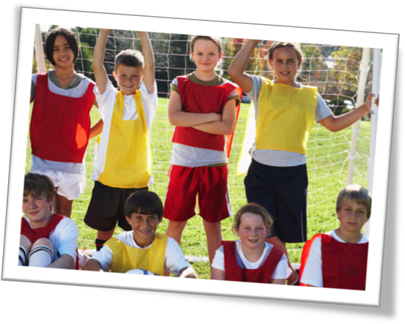

#### Sed tincidunt nisl a elit

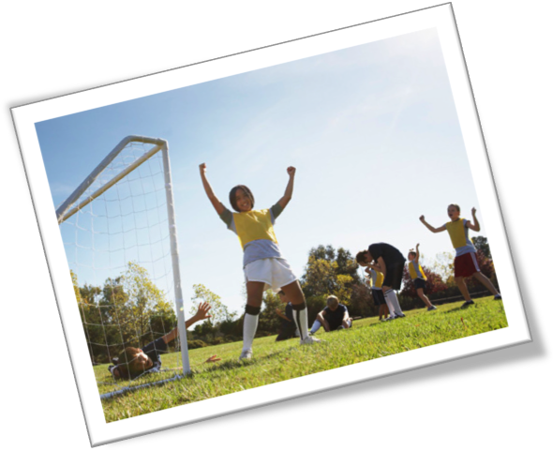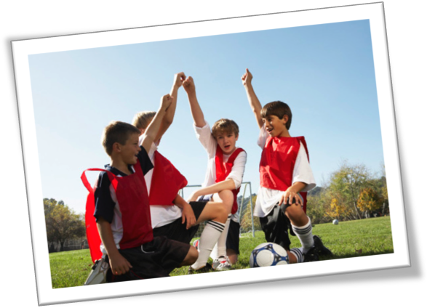

Justo id eleifend faucibus, urna dolor consectetuer dui, vel pretium risus purus sed pede. Integer diam elit, facilisis eget.

Morbi justo. Cras rutrum sapien non risus. Nam nibh erat, auctor sit amet, commodo ut, ornare id, ante. In imperdiet.

Morbi turpis libero, pretium vitae, imperdiet ut, dictum consequat, odio. In a libero. Integer lobortis. Maecenas porttitor dolor non eros.

Donec varius, felis eget lobortis vehicula, magna sapien elementum tellus, ut iaculis dui orci sed arcu. Nullam semper leo.

Consectetuer adipiscing elit. Suspendisse hendrerit ligula eget odio. Sed erat nisi, rhoncus id, imperdiet quis, blandit et, felis. In at nulla mattis neque commodo venenatis. Cras ultrices tincidunt risus. Quisque dictum diam adipiscing arcu. Proin enim. In diam turpis, suscipit fringilla, dapibus quis, dictum ut, ipsum. Phasellus id elit in dui bibendum bibendum.

Praesent vitae nisl.

[Street Address]  
[City], [State][Postal Code]

[Address Line 1]  
[Address Line 2]  
Address Line 3]

### [Recipient]

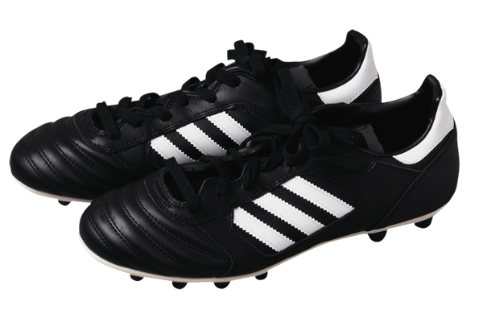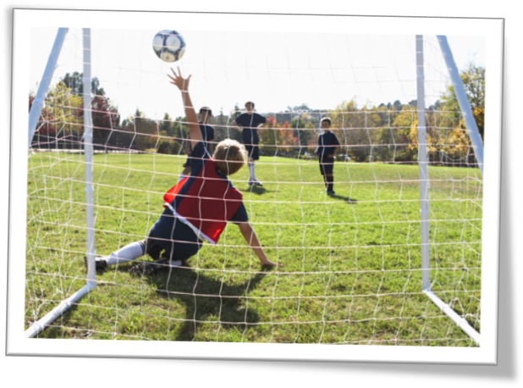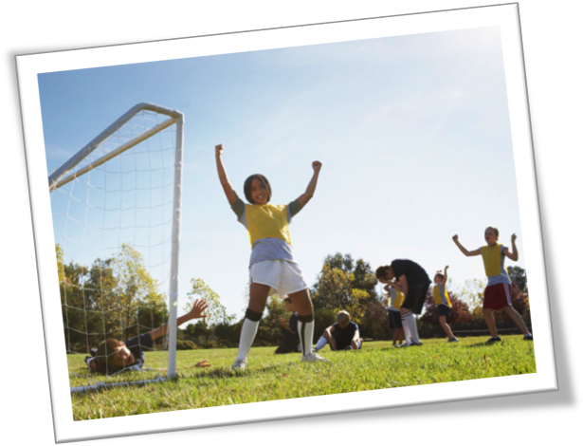

*Vestibulum ante ipsum primis in faucibus orci luctus et ultrices posuere cubilia Curae; Cras ornare dui ut neque. Pellentesque dignissim, ligula non dictum lobortis, pede arcu sodales odio, sit amet aliquam lorem arcu non quam. Suspendisse potenti.*

#### Lorem Ipsum Dolor

Cras posuere, velit nec rutrum auctor, velit augue feugiat orci, nec ornare urna quam ac massa. Nullam porta, mauris tempor sollicitudin varius, diam ipsum imperdiet massa, eu sagittis pede diam sit amet nisi. Fusce vitae ligula ac nunc elementum dignissim. Nullam rhoncus mi eu arcu. Donec ac nisi. Fusce sed mi non dolor consectetuer luctus. Cum sociis natoque penatibus et magnis dis parturient montes, nascetur ridiculus mus. Integer sit amet lectus. Curabitur cursus nisi eu enim. Vivamus in metus dictum purus fringilla eleifend. Aenean ultricies erat ac neque. Pellentesque luctus.

In hac habitasse platea dictumst.