

SARAH REDFERN HIGH SCHOOL

PDHPE FACULTY

ASSESSMENT TASK: 2 YEAR / STAGE: Stage 6 Year 11

DUE DATE: Friday 15th June, 2012.

TITLE: Core 2 – The Body in Motion

WEIGHTING: 20%

Learning Outcomes:
P7 Explains how body structures influence the way the body moves.
P8 Describes the components of physical fitness and explains how they are monitored.
P9 Describes biomechanical factors that influence the efficiency of the body in motion.
P17 Analyses factors influencing movement and patterns of participation.

Context:
During this unit of work we have studied the major functions of the human body and how these systems contribute to movement. We have also discussed the components of fitness, how to assess these and how devise methods to improve them. Biomechanics is the study of how the body can move efficiently and we have discussed these major laws of motion in class.

Task Description:
Use the diagram of the Discus thrower below to analyse the body in motion.

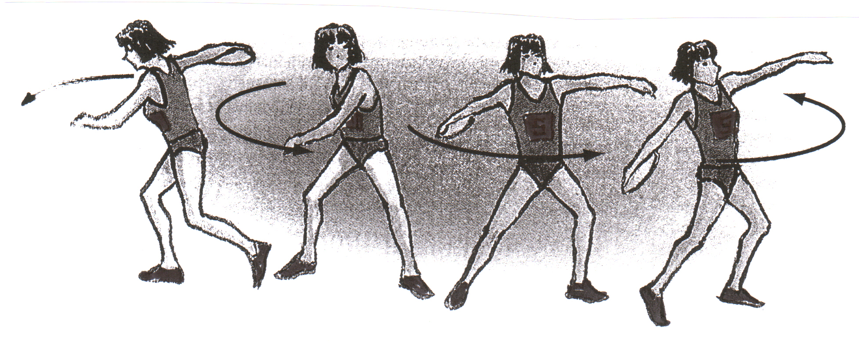

3 4 5 6

(a) Identify the joint action and muscles used at the hip, knee and elbow joints in phases 4, 5 and 6 of the movement. (5 marks)
(b) Describe the health- and skill-related components of physical fitness that are relevant to the performance of this skill. Select two of the health- and skill-related components and describe a test to measure each. The tests should be significant to the performance of this skill. (5 marks)
(c) Analyse the skill in order to determine the biomechanical principles that may impact on the efficiency of movement in the performance of this skill. (5 marks)

Criteria for Assessing Learning:
Your task will be marked according to your ability to:

• describe major muscles, specific joints and the actions of joints used to perform this movement
• demonstrate an understanding of how these structures influence the way the body moves
• classify and describe the health- and skill-related components of physical fitness required to perform the skill
• select two tests that are relevant to the fitness requirements in performance of this skill
• describe testing procedures and explain how to interpret the results
• analyse a skill or part of a skill in order to determine the biomechanical principles that influence how efficiently the skill is performed.

How to approach the assessment task

You will be required to analyse the action used in a Discus Throw

- Identify the joints, joint action and muscles used in the two sequences as highlighted on the diagram.

- Health and skill-related components
-> list them and give definitions of each
-> select two components and describe a test to measure each

- Biomechanical principles
-> motion (linear, angular, general)
-> speed
-> acceleration
-> momentum
-> force – internal forces, external forces e.g. gravity, air resistance, weight, friction, ground reaction force; applied and reaction forces
-> power
-> balance (static / dynamic)
-> centre of gravity

Name: ______________________

Marking criteria & student feedback sheet

Part A
Guidelines | Marks | Comments
- Clearly identifies the joints, joint actions and specific muscles used to perform the field event | 4 - 5
- Identifies some of the joints, joint actions and specific muscles used to perform the field event | 2 - 3
- Identifies a few of the joints, joint actions and specific muscles used to perform the field event | 1
- No relevant information | 0

Part B
Guidelines | Marks | Comments
- Thorough description of the major components of physical fitness required for the field event. Accurate classification of components as health or skill-related.  - The choice of tests demonstrates clear understanding of the significance of the identified components to the performance. Excellent description of the testing procedures. | 4 - 5
- Describes the major health and skill-related components of physical fitness required for the field event.  - The choice of tests indicates a basic understanding of how these components relate to the field event. Basic description of the testing and monitoring procedures. | 2 - 3
- Outlines some components of physical fitness.  - The choice of tests shows limited understanding of the components relevant to the field event. | 1
- No relevant information | 0

Part C
Guidelines | Marks | Comments
- Demonstrates extensive knowledge and understanding of biomechanical principles.  - Accurately describes and explains the biomechanical principles that influence the efficiency of movement in the field event | 4 - 5
- Demonstrates a broad awareness of biomechanical principles.  - Broadly describes the biomechanical principles that influence the efficiency of movement in the field event. | 2 - 3
- Provides some relevant information about the biomechanical principles that influence the field event. | 1
- No relevant information | 0

Total Marks : / 15

