11 PDHPE

Enjoy your long weeked…

ALL TASKS TO BE COMPLETE BY PERIOD 1
TUESDAY, 29TH MARCH, 2016

Re-answer Quiz Booklet Question on the ‘Meanings of Health’
A copy has been provided.
Task 1

Complete your Core 1 Summary. I have included the syllabus points that should be covered.
Do this on separate paper, which can be put into your summary folder. (It will take more than 1 piece of paper)
Task 2

Using the A3 paper provided. (yes old school)
You are to design a poster on the ‘JOINT ACTIONS’
Include a drawn diagram of each action, its description and a sporting example.
Refer to Pg 144-145 of textbook

Task 3

Joint Actions

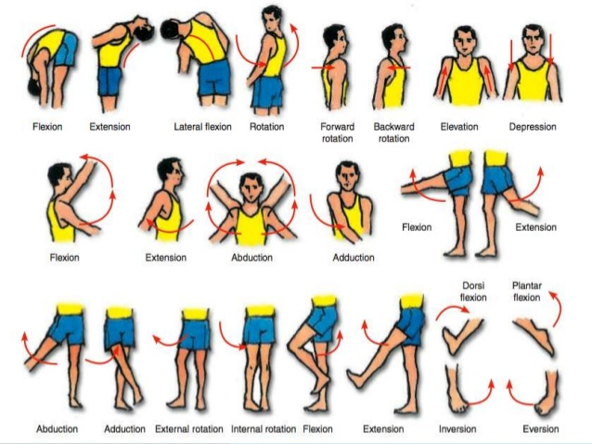

Syllabus points

- the degree of control individuals can exert over their health  - modifiable and non-modifiable health determinants  - the changing influence of determinants through different life stages |  | - assess the degree of control individuals have over their health, by exploring questions such as:  - how much control do individuals have over the determinants?  - what can individuals do to modify the determinants they have little control over?  - how does the level of influence of the determinants change over time?
- health as a social construct  - recognises the interrelationship of determinants  - challenges the notion that health is solely an individual’s responsibility. |  | - investigate how the determinants of health explain why some individuals and groups have better or worse health than others.
What strategies help to promote the health of individuals?
Students learn about: | Students learn to:
- what is health promotion  - responsibility for health promotion  - individuals  - community groups/schools  - non-government organisations  - government  - international organisations, eg WHO, United Nations | - describe the various health promotion roles and responsibilities adopted by individuals, groups and governments

- health promotion approaches and strategies  - lifestyle/behavioural approaches, eg quit smoking programs, health education  - preventative medical approaches, eg childhood immunisation, cancer screening  - public health approaches, eg health-promoting schools and workplaces | - determine the effectiveness of a range of health promotion strategies relevant to young people, eg government interventions relating to alcohol consumption and young drivers  - propose other actions that may improve the health of young people
- the Ottawa Charter as an effective health promotion framework  - developing personal skills  - creating supportive environments  - strengthening community action  - reorienting health services  - building healthy public policy | - describe the historical significance of the Ottawa Charter for Health Promotion  - explain how health promotion based on the action areas of the Ottawa Charter have contributed to positive health outcomes. For example:  - reduction in road injuries  - reduction in tobacco use
- principles of social justice  - equity  - diversity  - supportive environments. | - identify strategies where the principles of social justice have been applied to promote the health of individuals.

